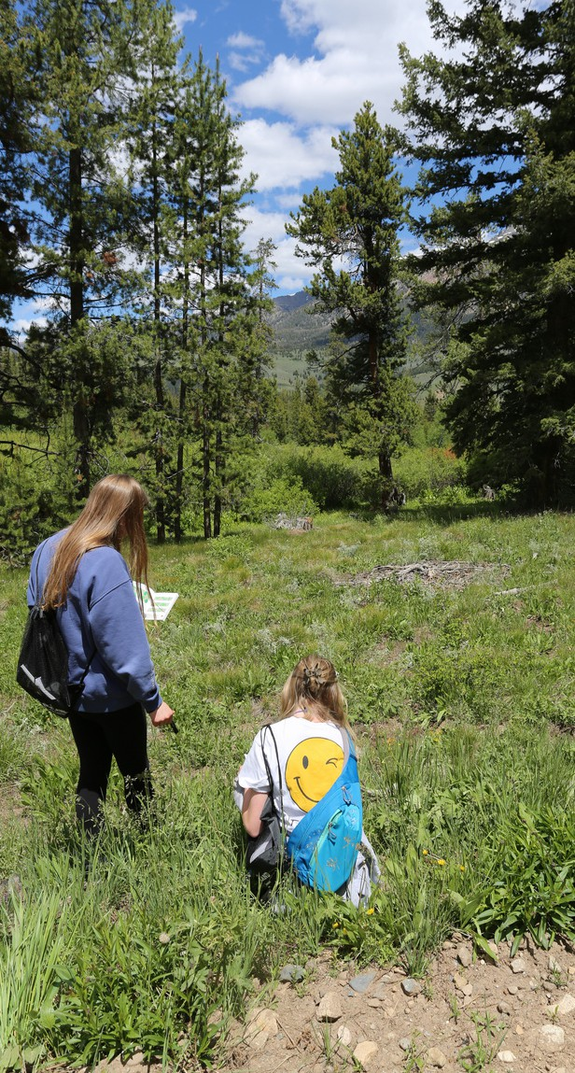
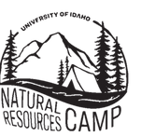


Wildlife
Let the animals do the teaching as they show you their habitats, communities, adaptations, and interactions.

Rangeland

Nearly one-half of Idaho is rangeland (about 21 million acres). Idaho rangelands are extremely valuable because they support many different uses, from recreation to livestock grazing and many more in between.

Soil

Soil is the basis for all life. Learn how soils vary across the landscape and the management practices that we use to determine their health and functionality.

Forest

The forest serves many key purposes in Idaho; from recreation to a source of fuel. Forests also protect our soil, store





Website

Camp Director
Randy Brooks rbrooks@uidaho.edu
(208) 885-6356

Assistant Camp Director
Hailey Ellerbroek elle2051@vandals.uidaho.edu
(208) 885-6356

our water, and keep the air clean for us to breathe.

Water

Water has been described as the elixir of life, the universal solvent, and the lifeblood of nations. Explore water quality issues of irrigation, municipal uses, recreational use, and pollution potential… and meet the tiny creatures that call our water their home!
uidaho.edu/extension/natural-resources/camp

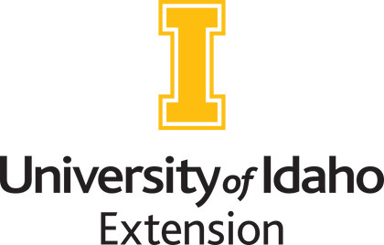

The University of Idaho provides equal opportunity in education and employment on the basis of race, color, religion, national origin, gender, age, disability, or status as a Vietnam-era veteran, as required by state and federal laws.

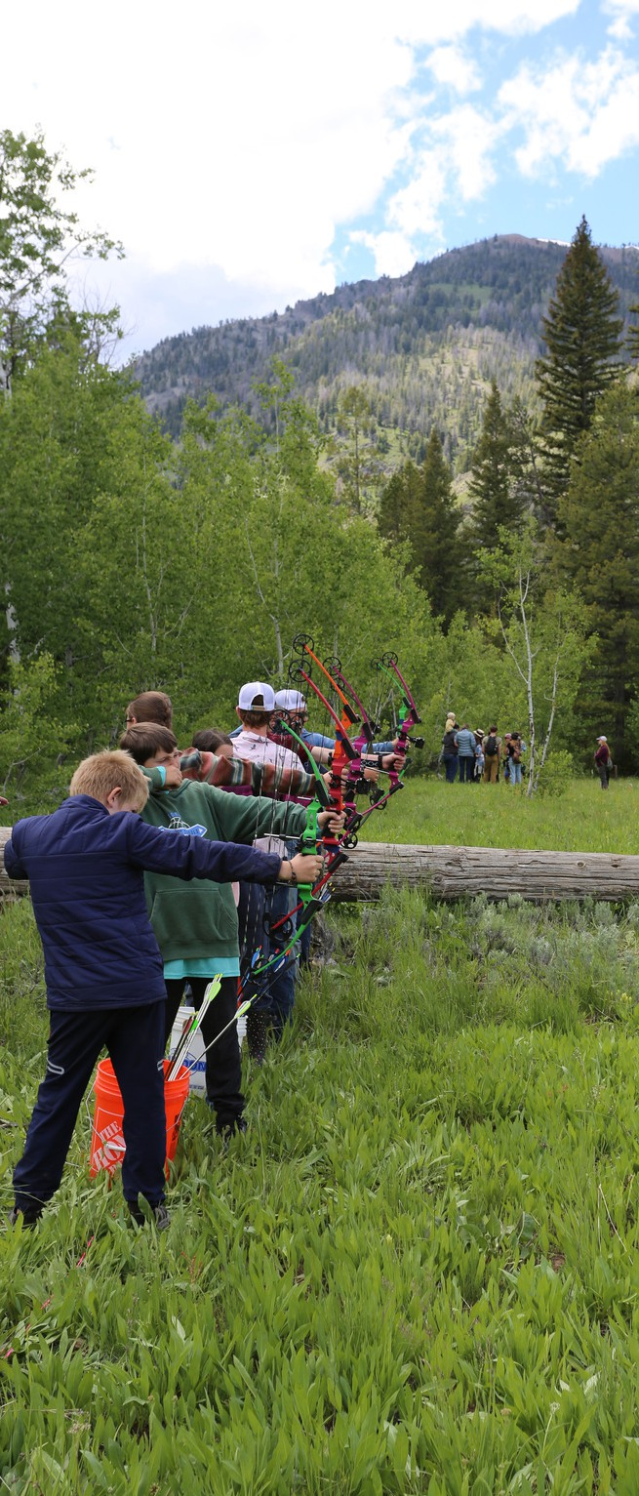
Adventure awaits!
Come spend a week near beautiful Sun Valley exploring and studying Idaho’s natural resources!
- Discover nature’s secrets for yourself through hands-on learning.
- Enjoy outdoor activities such as hiking, fishing, volleyball, archery, survival, target shooting, and fireside sing-alongs.
- Make lifelong friends!

Camp Information
WHEN | June 15-20, 2026
- Arrive Monday, June 15th between 12:30 and 1:30 p.m. MDT.
- Camp ends at 10:30 a.m. MDT Saturday, June 20th.
WHERE | Central Idaho 4-H Camp (Milepost 146 on Hwy. 75)
- Transportation to and from camp is the parent/guardian responsibility.

WHO | Eligible campers must be at least 12 and no older than 16.

Registration
The cost to attend Natural Resources Camp is $ 310 per camper. Please contact your county’s Soil and Water Conservation District for scholarship opportunities.
Completed applications are due by May 20, 2026. Camp applications can be obtained at the following locations:
- Your local Soil & Water Conservation District
- Your County Extension Office or,
- On our website at: https://www.uidaho.edu/extension/natural-resources/camp

